Nama : Pramudea Yohano Firmansyah

NPM : 5200411409

Prodi : S1 – Informatika

“**SQL DML Sintak**”

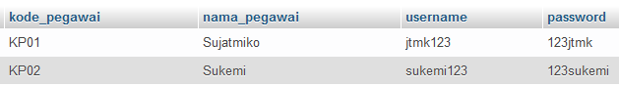

1. SELECT





1. INSERT



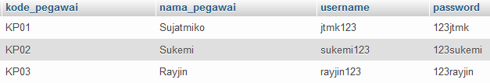

1. UPDATE





1. DELETE



